Project Approach (Roadmap)
Tourism Analytics using Predictive and Descriptive Data Mining Techniques

Domain
Tourism & Hospitality Analytics (Predictive and Descriptive Data Mining)

Dataset
I recommend using three benchmark datasets together:
- Hotel Booking Demand Dataset (booking, cancellation, and occupancy records from city and resort hotels)
https://www.kaggle.com/datasets/jessemostipak/hotel-booking-demand
- UNWTO Tourism Statistics Database (global and regional inbound/outbound tourist arrivals and expenditure)
https://www.unwto.org/tourism-statistics/tourism-statistics-database
- New York City Airbnb Open Data (short-term accommodation listings, pricing, and neighbourhood-level demand)
https://www.kaggle.com/datasets/dgomonov/new-york-city-airbnb-open-data
All three are well-established, valid datasets. All are to be considered in the project.

Abstract

Abstract Educational institutions generate large volumes of academic, demographic, and behavioural data that can be utilized to understand student learning patterns and predict academic performance. However, conventional predictive models often function as black-box systems, providing accurate predictions without explaining the factors influencing those outcomes. This lack of interpretability limits the confidence of educators and academic administrators in adopting data-driven decision-making. To address this challenge, this project proposes an Explainable Artificial Intelligence (XAI)-based framework for Student Academic Performance Analytics by integrating comprehensive Exploratory Data Analysis (EDA), machine learning, and explainability techniques.

The proposed framework utilizes three widely recognized benchmark datasets: the UCI Student Performance Dataset, xAPI Educational Dataset, and the Open University Learning Analytics Dataset (OULAD). Initially, the datasets undergo data preprocessing, including missing value handling, categorical data encoding, and normalization to improve data quality and consistency. A detailed Exploratory Data Analysis (EDA) is then performed to gain meaningful insights through dataset overview, data quality assessment, descriptive statistics, missing value analysis, duplicate record detection, outlier detection, univariate, bivariate, and multivariate analyses, correlation analysis, feature engineering, and feature selection.

Following preprocessing and EDA, multiple machine learning algorithms, namely Logistic Regression, Decision Tree, Random Forest, XGBoost, and CatBoost, are trained and evaluated for predicting student academic performance. The performance of these models is assessed using standard evaluation metrics, including Accuracy, Precision, Recall, F1-Score, and ROC analysis. To enhance transparency and interpretability, the framework incorporates SHAP (SHapley Additive explanations) and LIME (Local Interpretable Model-agnostic Explanations), enabling both global and local explanations of model predictions. These techniques help identify the most influential features affecting student performance, thereby making the prediction process understandable to educators and stakeholders.

Furthermore, the analytical results are presented through interactive visualizations such as heatmaps, boxplots, feature importance graphs, and dashboards, facilitating effective interpretation of the data and model outcomes. Finally, a comparative analysis is conducted across all machine learning models to determine the most effective and explainable approach for student performance prediction. The proposed research framework combines educational data mining, learning analytics, machine learning, and explainable AI into a unified analytical pipeline. The project aims not only to achieve high predictive performance but also to provide transparent and interpretable insights that support evidence-based academic interventions, student success strategies, and informed educational decision-making. give this in accordance with my project

Data Analytics

EDA
EDA Flow Diagram:
Raw Dataset
↓
Dataset Overview
↓
1. Data Quality Assessment
↓
2. Descriptive Statistics
↓
3. Missing Value Analysis
↓
4. Duplicate Records Detection
↓
5. Outlier Detection
↓
6. Univariate Analysis
↓
7. Bivariate Analysis
↓
8. Multivariate Analysis
↓
9. Correlation Analysis
↓
10. Time-Series Trend & Seasonality Analysis
↓
Feature Engineering
↓
Feature Selection
↓
Data Mining Models

The EDA section includes 10 core analytical techniques (numbered above) rather than limiting it to basic plots.
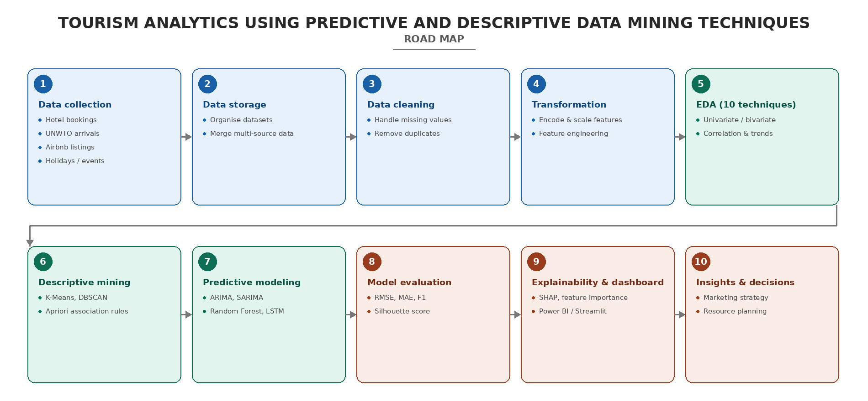

Preprocessing
- Missing values
- Encoding (country, market segment, room type, distribution channel)
- Normalization / Scaling
- Date-time feature extraction (month, season, holidays, weekends)
- Time-series resampling & stationarity checks (for ARIMA/SARIMA)

Data Mining Models

Descriptive Techniques
- K-Means Clustering — tourist segmentation by demographics and preferences
- DBSCAN — density-based segmentation for irregular travel clusters
- Apriori Algorithm — association rule mining for travel package combinations

Predictive Techniques
- ARIMA / SARIMA — time-series forecasting of tourist arrivals
- Decision Tree & Random Forest — predicting booking behaviour and cancellations
- LSTM Neural Network — capturing complex, non-linear seasonal demand patterns

Explainability
- SHAP — feature-level explanations for Random Forest / Decision Tree predictions
- Feature Importance — key drivers of cancellations and demand
- ACF / PACF Plots — interpretability for ARIMA / SARIMA forecasts
- Elbow & Silhouette Plots — interpretability for clustering (K-Means / DBSCAN)
- Dashboard — interactive visualization for stakeholders

Comparative Analysis
Compare
Category | Models Compared
Clustering | K-Means vs DBSCAN
Forecasting | ARIMA vs SARIMA vs LSTM
Classification | Decision Tree vs Random Forest

Metrics
Task | Evaluation Metrics
Clustering | Silhouette Score, Davies–Bouldin Index
Forecasting | RMSE, MAE, MAPE
Classification | Accuracy, Precision, Recall, F1, ROC-AUC

Recommended Research Pipeline
Benchmark Tourism Datasets
↓
Data Cleaning
↓
EDA
↓
Feature Engineering
↓
Feature Selection
↓
Train-Test Split
↓
Descriptive Models (K-Means, DBSCAN, Apriori)
↓
Predictive Models (ARIMA, SARIMA, Decision Tree, Random Forest, LSTM)
↓
Performance Evaluation
↓
Model Interpretability (SHAP + Feature Importance)
↓
Visualization Dashboard (Tableau / Power BI / Streamlit)
↓
Comparative Analysis
↓
Research Conclusions & Recommendations

Conclusion
By combining descriptive and predictive data mining techniques, this project provides a holistic framework for tourism analytics. The approach enables stakeholders to understand historical patterns while preparing for future demand, ultimately leading to smarter, data-driven tourism management.
Tourism demand is highly volatile due to seasonal variations, socio-economic factors, and global disruptions. Traditional statistical methods often fail to capture these complexities, leading to inaccurate forecasts and inefficient planning. There is a need for a robust framework that combines descriptive analytics (to explain the past) and predictive analytics (to anticipate the future) using modern data mining and AI/ML techniques.

BY:
BATCH NO:4
G. HASINI-2420030421
S. RISHITHA-2420090060
G. KEERTANA-2420090075

